1. **Audemars Piguet Royal Oak 34mm Silver Dial Watch**

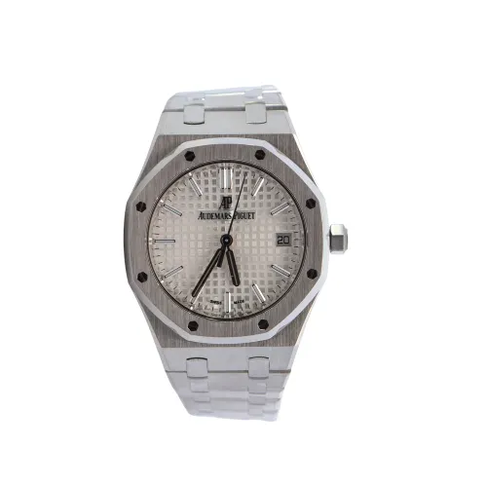

* **Price:** Around $30,451.
* **Description:** This is a luxury Swiss watch, known for its distinct octagonal bezel and timeless design. Highly sought-after by watch collectors for its blend of elegance and engineering.
* Often seen as a statement piece among timepiece enthusiasts.[1]

1. **Rolex Yacht-Master 42mm Black Dial**

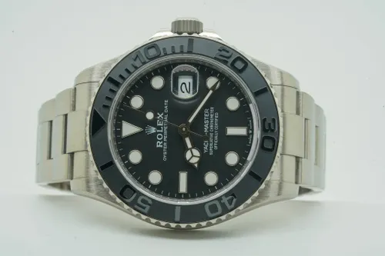

* **Price:** Around $31,680.
* **Description:** Rolex’s Yacht-Master series is celebrated for combining functionality and style. The 42mm version in black is a modern classic that appeals to investment-minded collectors as well as luxury aficionados.[1]

1. **Subodh Gupta Sculpture “Gober Ganesha”**

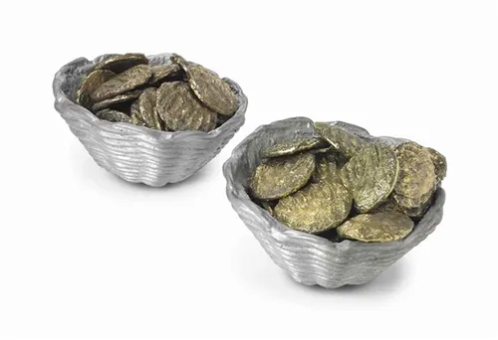

* **Price:** Realised at $40,000 at auction.
* **Description:** A contemporary art piece by renowned Indian artist Subodh Gupta, "Gober Ganesha" is prized for its cultural symbolism and unique materials. Gupta’s works regularly feature in high-profile exhibitions and auctions.

1. **Patek Philippe Calatrava 40mm Black Dial Watch**

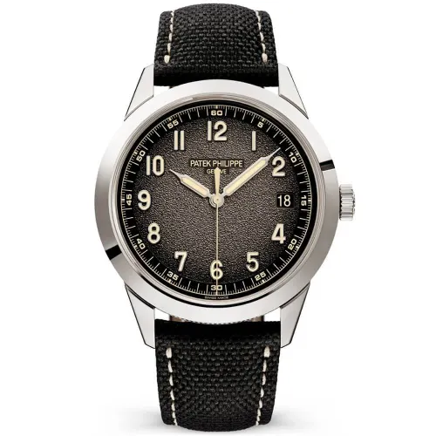

* **Price:** Around $33,000.
* **Description:** Patek Philippe is iconic in luxury watchmaking, and the Calatrava series is revered for its simplicity and elegance. The 40mm version with a black dial is amongst the most collectible vintage watches.

1. **Vintage Paintings (Oil Paintings in Ornate Frames)**

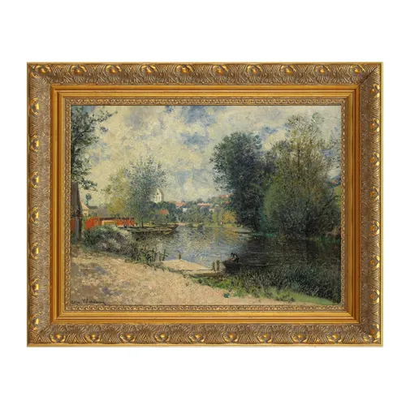

* **Price:** Often $30,000–$40,000 for large, signed pieces with provenance.
* **Description:** 19th and early 20th-century oil paintings frequently bring these prices at auction, especially those with luxurious, original frames and clear documentation of their creator and history.[3]

Images for these specific items can be sourced from luxury watch dealers, contemporary art auction galleries, and reputable art/antique auction sites like Sotheby’s and Christie’s.

These collectibles are accessible to upper mid-tier collectors and frequently auctioned in both specialized and general markets. Their value is supported by quality, provenance, and the prestige of their makers or artists.